Flow Chart of the Automatic Operation

The flow chart outlines the logic and sequence of operations for the automatic control of the propeller-driven cart. Below is a textual description of the flow chart:

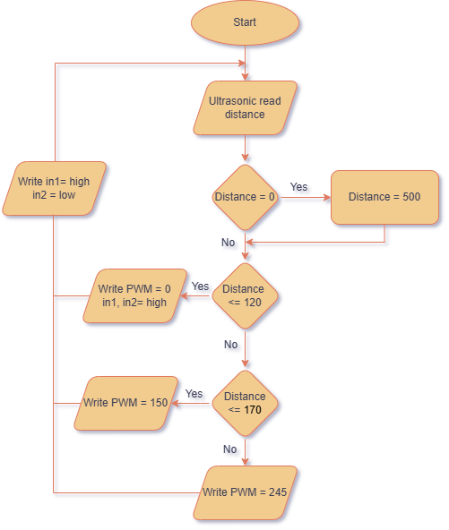

Code Overview:
The Arduino code controls the kinematics of the vehicle by reading the distance from the ultrasonic sensor and adjusting the motor speed accordingly. Below is a breakdown of the code:
Key Components:
- Ultrasonic Sensor:
  - Measures distance using the NewPing library.
  - Triggers and listens for the echo to calculate distance.
- Motor Control:
  - Uses PWM to control motor speed.
  - Implements braking by setting both motor pins (IN1 and IN2) to HIGH.
- Kinematics Logic:
  - Acceleration: Gradually increases speed when distance > 170 cm.
  - Deceleration: Reduces speed when distance is between 120 cm and 170 cm.
  - Stop: Activates braking when distance ≤ 120 cm.
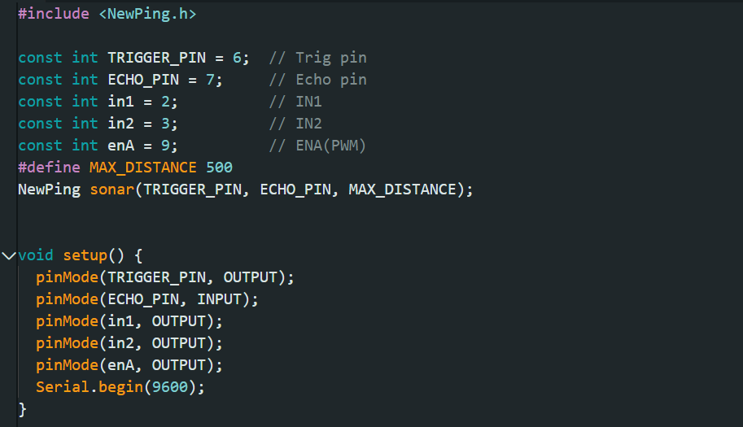

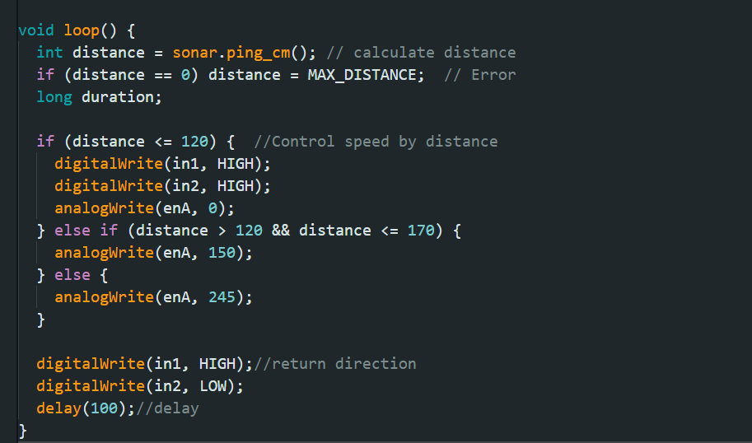

Kinematics Calculations:
- Acceleration:
  - The cart accelerates from rest to almost max speed when the distance > 170 cm.
  - Acceleration is controlled by gradually increasing the PWM signal from 0 to 255.
$$d= υ_{0}.t+\frac{1}{2}a.t^{2}$$
$$υ_{f}= υ_{0}+a.t$$

 | 5 meters | 3 meters | 2 meters
D(m) | 2 | 1.2 | 0.3
T(sec) | 4 | 3.74 | 1.8
A(m/sec^2) | 0.25 | 0.23 | 0.18
V(m/sec) | 1 | 0.86 | 0.324

- Constant Speed:
  - The cart maintains a constant speed when no obstacles are detected (distance > 170 cm).
$$v= \frac{d}{t}$$
 | 5 meters | 3 meters | 2 meters
D(m) | 1.3 | .3 | 0
T(sec) | 1.3 | .35 | 0
V(m/sec) | 1 | 0.86 | 0.324

- Deceleration:
  - The cart decelerates to 70% speed when the distance is between 120 cm and 170 cm.
  - Deceleration is controlled by reducing the PWM signal from 245 to 150.
$$υ_{f}= υ_{0}+a.t$$

 | 5 meters | 3 meters | 2 meters
D(m) | 1.5 | 1.2 | 1
T(sec) | 2.34 | 2 | 1.8
V final (m/sec) | 0 | 0 | 0
A(m/sec^2) (-) | 0.43 | 0.43 | 0.18

- Stop:
  - The cart stops completely when the distance ≤ 120 cm.
  - Braking is achieved by setting both motor control pins (IN1 and IN2) to HIGH.

